Donation Form | 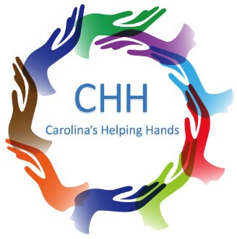
Carolina’s Helping Hands is a non-profit organization that focuses on providing help where it is needed. The core of our work lies in the continuous passion and dedication we bring to the range of projects we take part in to make a meaningful difference in the lives of others and communities.

Donor Information
BUSINESS NAME | NAME (LAST, FIRST, M.I.)
STREET ADDRESS | EMAIL
CITY, STATE, ZIP | PHONE
WEBSITE | ALTERNATE PHONE

Donation Description
CHECK ONE: CASH PRODUCT / ITEM SERVICE OTHER
AMOUNT / DESCRIPTION | DATE
PLEASE APPLY MY DONATION TO A SPECIFIC INTEREST: _________________________________________________________

PLEASE APPLY MY DONATION TO CAROLINA’S HELPING HANDS NON-PROFECT GENERAL FUND ACCOUNT
NOTES

Contact Information
Carolina’s Helping Hands  Employer ID# 88-3938874  carolinashelpinghands.com | Carolyn Hogg  President  Email: CarolinasHelpingHands@gmail.com

